BT Transmitter, Channel Noise, Receiver, BER

The objective of this lab is to design the Bluetooth (BT) Transmitter and combine it with the receiver -
For example, see https://edadocs.software.keysight.com/display/ads2009/BlueTooth+Example+System#BlueToothExampleSystem-Analysis

https://edadocs.software.keysight.com/display/ads2009/Bluetooth+DesignGuide+Reference#BluetoothDesignGuideReference-DevelopingorIntegratingaBluetoothSolution

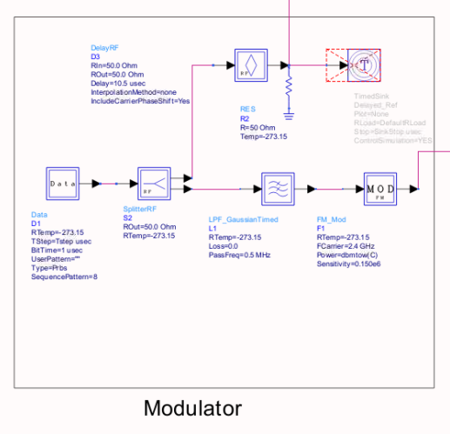

Adding Channel noise: The objective is to examine the transmitter signal losses and noise when it gets to the Rx – Add channel noise (30)

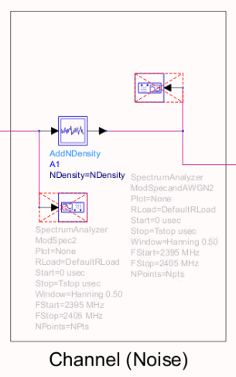

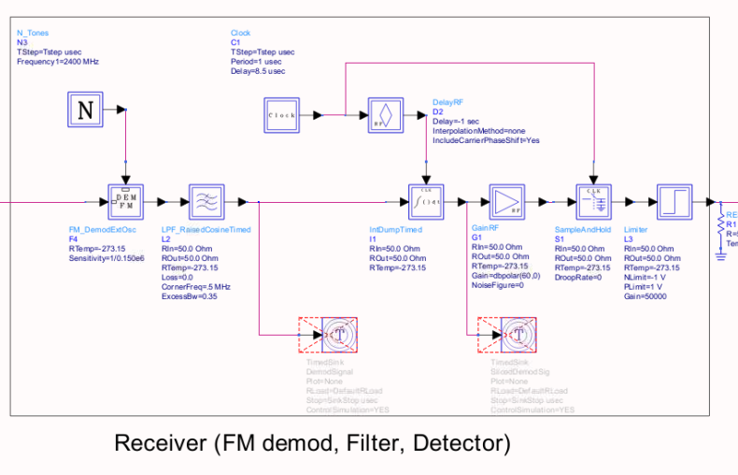

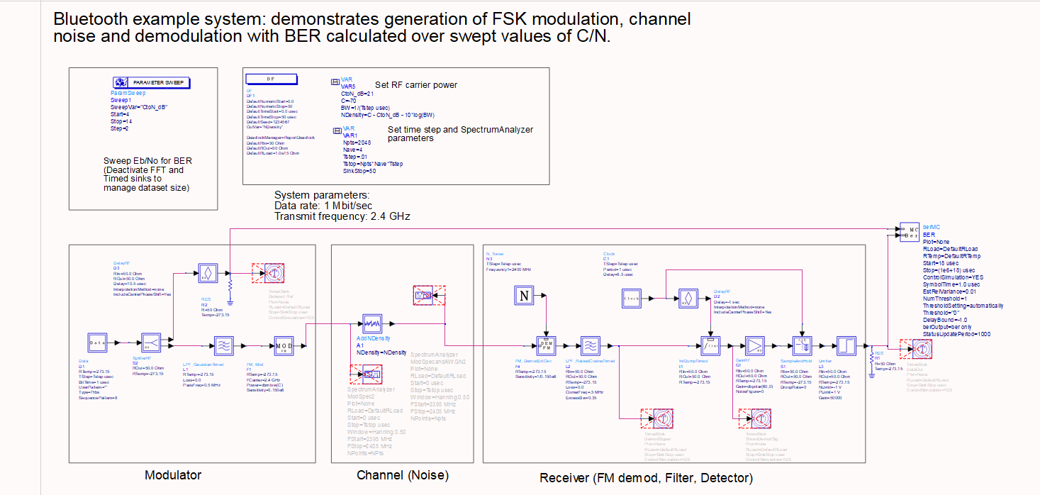

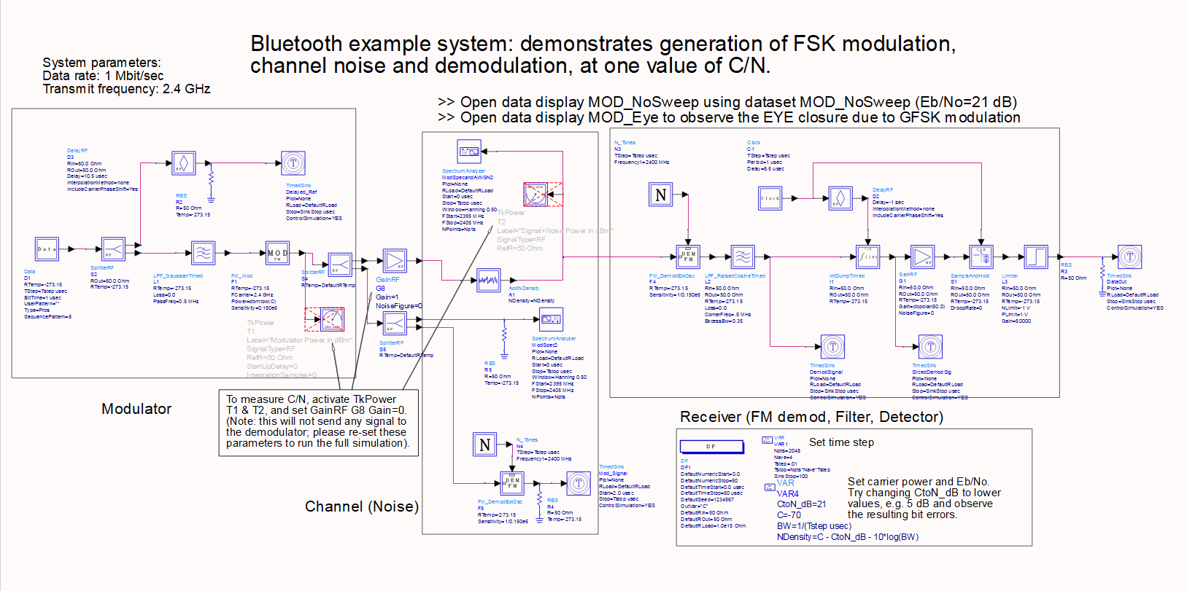
Appendix – Tutorial on Harmonic Balance and Budget Analysis

For the link budget, you can choose XLS, MATLAB, or the ADS

- ADS Budget Analysis

In order to observe total NF and gain you can run a budget analysis simulation.
ADS already has a setup and you can use it if you follow these steps:

- Advanced design system main window -> file -> open -> example …
- In the new window search “budget” and press enter.
- In Budget Analysis window click on “open workspace: Archive_ … “
- Click finish in the new window.

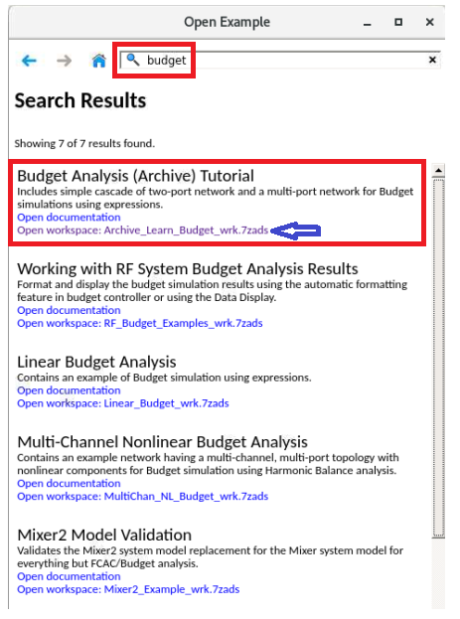

- After unarchiving the library click on the linear budget and run it.

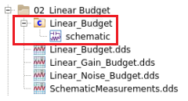

- Learn the setup and later, modify the schematic to your own receiver.
- Plot NF and Gain for the receiver for each stage.

- Harmonic Balance: Multiple tone test

At the input of receiver, define the following tones:

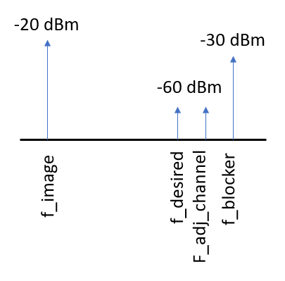

- In this simulation you will plot output spectrum after each stage. You are going to work with voltage since matching is ignored for some tones and if you use power you cannot observe any results. Plot all your results in dB

- Define following 6 tones in harmonic balance setup.
- Explain how you calculated each of them.

- f_in (desired channel)
- f_adjch (adjacent channel)
- f_block (blocker)
- f_im (image)
- flo1 (Mixer 1 LO)
- flo2 (Mixer 2 LO)

- Choose flo1 and flo2 in order to have IF1=450 MHz and IF2=10 MHz
- Design your band-select and image rejection filter in order to have

You will be choosing the following parameters for BPF filters (as shown in the figure below):

- For band-select filter, N=1 and for image reject filter N=2
- IL: Insertion loss. IL =NF (for RF filters only)
- The image should be rejected by 60dB to 80dB at the input of first mixer.

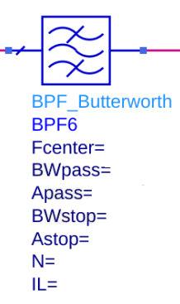

- Choose compression point for LNA in order to achieve minimum gain of 10dB after desensitization.
** Hint **
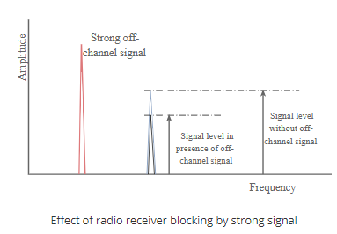

- For mixers increase the comp point to be more than LNA and define a conversion gain.
- After mixer use a low pass filter (can be LPF_Elliptic) to do channel selection.
- For IF filter you can use higher orders N<=10
- IF filter should have amplification and noise figure. you can use a cascaded block to model these filters:
